 | ALPS Mountaineering | http://www.alpsmountaineering.com/
 | Big Agnes | Slater UL3+, 2.44 кг, $549.95  https://www.bigagnes.com  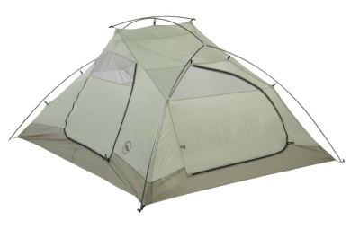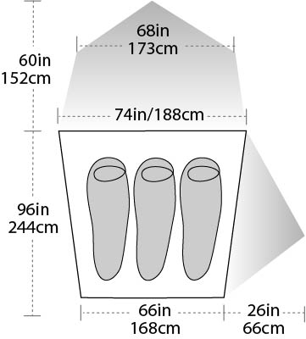
 | Black Diamond | SQUALL TENT, 3.82 kg, $599.95.  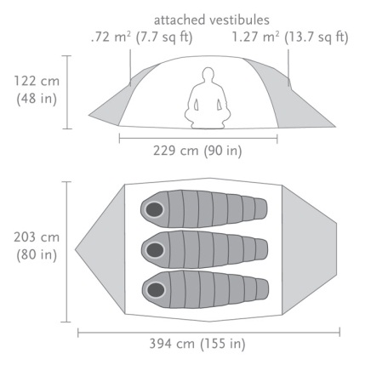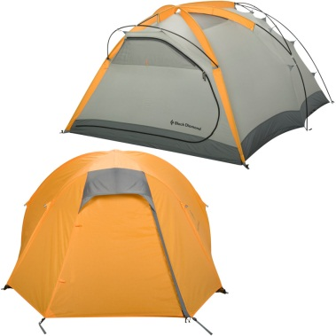
 | Coleman | http://www.coleman.com/
 | CampTrails | http://www.camptrails.eu/c/tents_view-all
 | Easton Mountain Products | http://eastonmountainproducts.com/
 | Eureka | http://store.eurekatent.com/tents
 | Exped | http://www.exped.com/
 | Ferrino | http://www.ferrino.it/en/catalog/tents
 | FORCE | http://www.forcetentents.com/
 | Jack Wolfskin | http://www.jack-wolfskin.com/equipment/tents.aspx
 | High Peak | http://www.highpeak-outdoor.com/index.php?t=p&id=1  http://highpeakusa.com/
 | Hilleberg | NALLO 4 GT - 3.6 кг, $940 http://www.hilleberg.com/home/products/nallo/nallo4gt.php  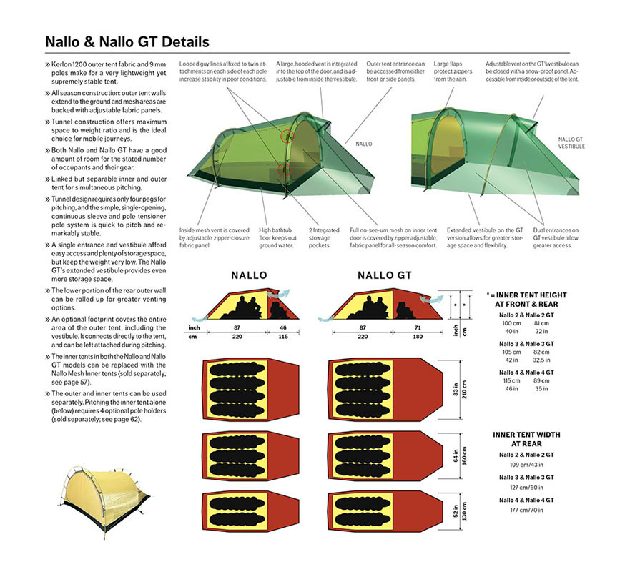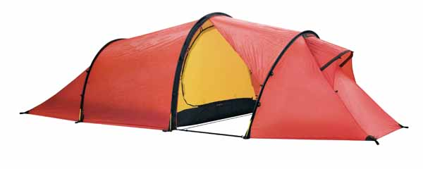
 | Kelty | http://www.kelty.com/c-tents-shelters.aspx
 | Lightwave | http://www.lightwave.uk.com/products/tents/lightwave-tents
 | Marmot | http://marmot.com/products/equipment/tents
 | MEC | MEC VOLT 3 TENT – 2,8 кг, $439  http://www.mec.ca/product/5027-681/mec-volt-3-tent/  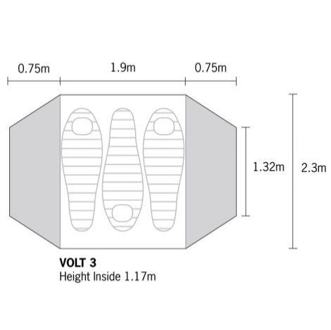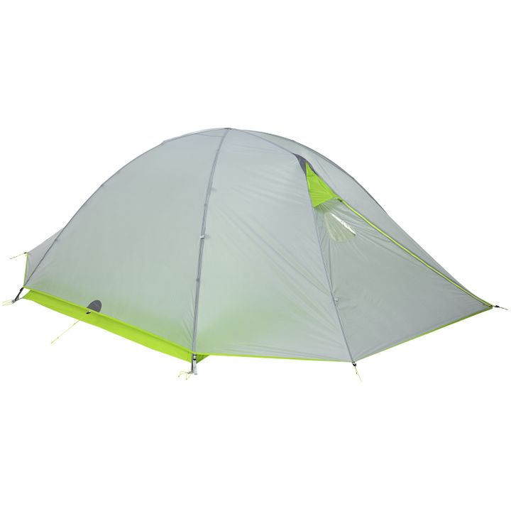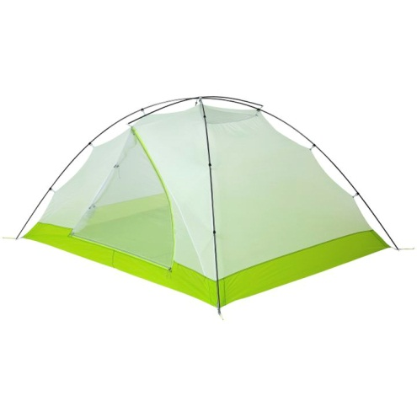
 | Mountain Equipment | http://www.mountain-equipment.com/tents-bivis
 | Mountain Hardwear | http://www.mountainhardwear.com/tents-outdoor-equipment-camping/
 | Mountainsmith | http://mountainsmith.com/index.php/products/all-tents.html#page=1
 | MSR | http://www.cascadedesigns.com/msr/tents/category
 | NEMO Equipment Inc. | http://www.nemoequipment.com/shop/tents/
 | Nordisk | Nordisk Oppland 3 (Nordland 3), 3.3кг, ~EUR 550  http://www.nordisk.eu/fgreen/products/tents/tents-detail/type/tents/categories/nordland-3/product_model/si/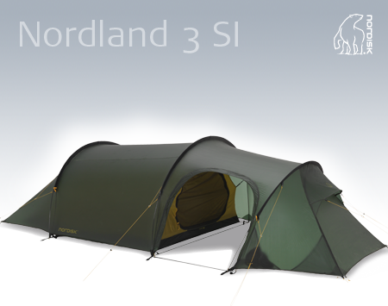 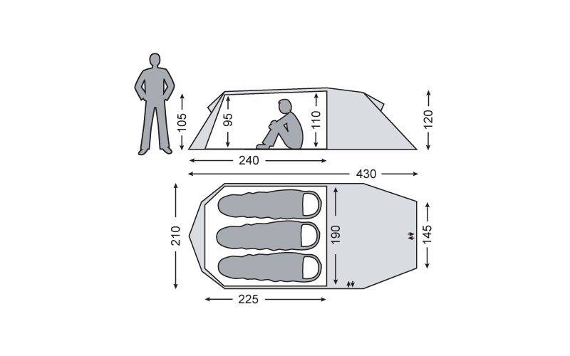
 | Paha Que | http://pahaque.com/prodBearCreek_v4.asp
 | Rab | http://rab.uk.com/products/equipment/
 | REI | http://www.rei.com/
 | Robens | Lodge 3, 3,7кг,  http://www.robens.de/en/Products/Tents/Trail/Lodge3.aspx  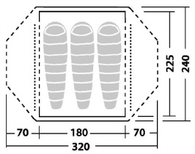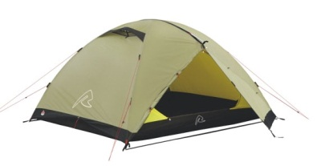
 | Salewa | http://www.salewa.com/tents
 | Sierra Designs | http://www.sierradesigns.com/tents
 | Snow Peak | http://www.snowpeak.com/shelters/tents.html
 | Talberg | Malm 3 pro, 3,6 кг, 8,5-9 т.р. http://talbergeu.com/catalog.php?id=2  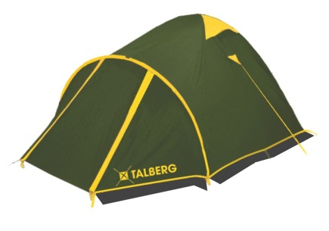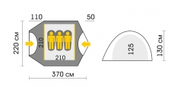
 | Terra Nova | http://www.terra-nova.co.uk/tents-and-spares/
 | The North Face | http://www.thenorthface.com/catalog/sc-gear/equipment-tents.html
 | VauDe | http://www.vaude.com/en-GB/Products/Tents/

